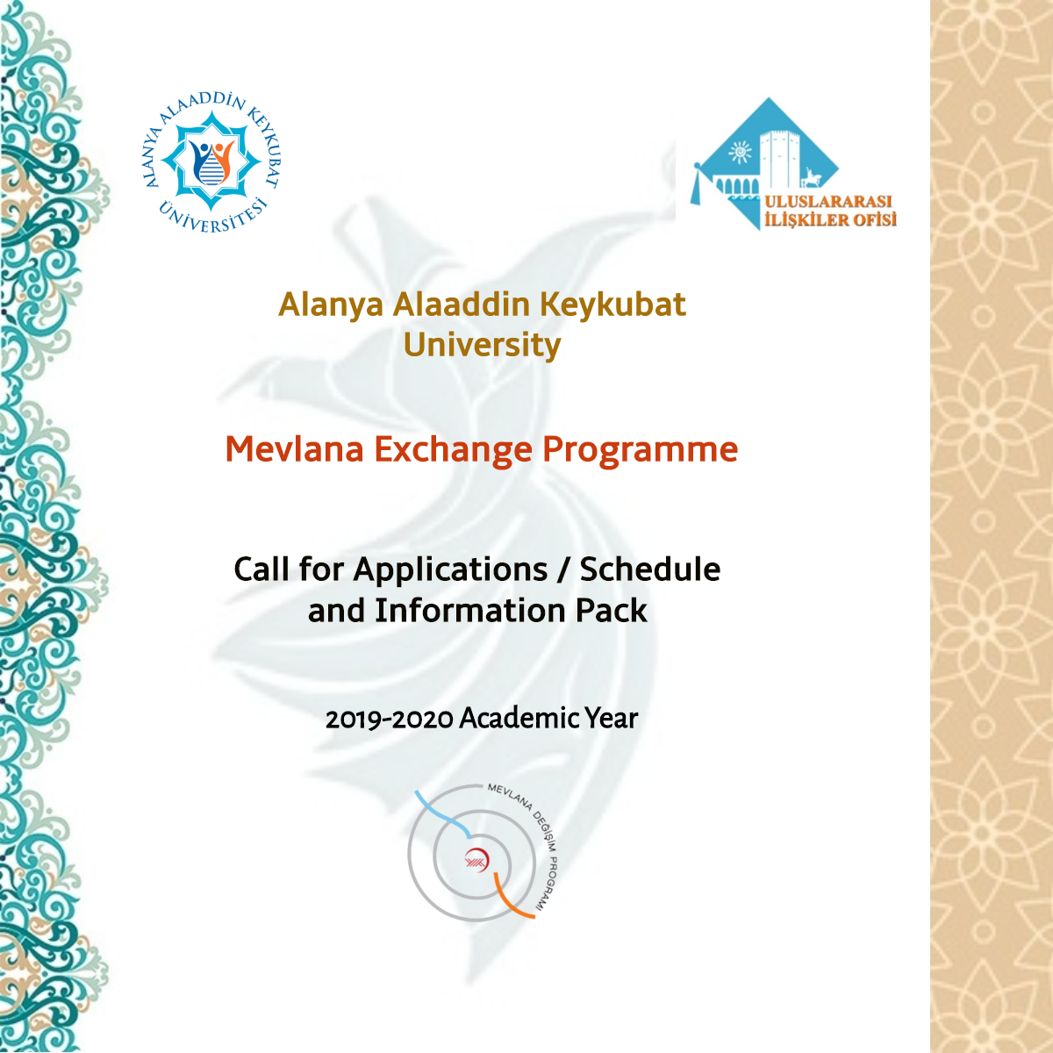

2019-2020 ACADEMIC YEAR MEVLANA EXCHANGE

PROGRAMME SCHEDULE AND INFORMATION PACK

FOR INTERNATIONAL OFFICES

Within the framework of “Regulation on Mevlana Exchange Programme” published in Official Journal on 23.08.2011 / no:28034 and “Principles and Procedures on Use, Accounting of the Amounts to be transferred to Higher Education Institutions and Other Relevant Matters on the Payments to be made in the Scope of Mevlana Exchange Programme” accepted in the Council of Higher Education Executive Board on 07.07.2011; the execution of Mevlana Exhange Programme by the signatory national higher education institutions and their international partners in 2019-2020 academic year is approved according to the below mentioned Schedule:

APPLICATION CALENDAR

 | Date | Place
Application Dates | 4th February –  28th February 2019 | International Relations / Mevlana Offices of the Relevant University
Sending Results of Applications to Alanya Alaaddin Keykubat University | 28th February 2018 | An e-mail should be sent to mevlana@alanya.edu.tr
Announcement of Results | April-May 2019 | International Relations Office web pages:  https://uio.alanya.edu.tr/  https://uio.alanya.edu.tr/index-EN
Receiving the Applications for the Exchange Programme | 04 February 2019 -  28 February 2019 (Deadline)

Incoming Students:

Required Documents:
- Candidate Student Application Form (You can find in the e-mail attachment.)
- Transcript
- Foreign Language Document

General Requirements:
- Must be eligible to study at the associate degree, bachelor’s degree, master’s degree or PhD
degree level in higher education programmes,
- The grade point average (GPA) of associate degree and undergraduate students must be at least 2.5/4.00
- The grade point average (GPA) of graduate students (MA, PhD) must be at least 3.00/4.00.

Special Requirements:
- Students attending preparation classes or scientific preparation programmes at graduate degree level are not eligible to participate in this programme during their first semester.

Language Score:
- The education language of Alanya Alaaddin Keykubat University is mostly in Turkish. However, we have some faculties that give education in English or partly in English. Therefore, the students’ language proficiency must be adequate to follow the courses in the host faculty.
One of the main criteria of selection for students is language score. However, there is not a standard language test or document defined by legislation to be accepted. The institutions may demand a national/international language test score, or they can measure the language level with an exam developed by their institution. The language proficiency of applicants is one of the core elements affecting the quality and success of the programme and student. Higher education institutions are supposed to be sensitive in this issue in the selection process of applicants.

- During the evaluation, 50% of grade point average and 50% of language scores are taken into account and students are ranked using cumulative value of these two factors so students must present their language score with a Language Exam and a Language Certificate.

Scholarship for Incoming Students:
Mevlana Exchange Programme students will continue to receive any scholarships or grants from their home countries, and they are required to register with their home institutions.
Incoming students to Alanya Alaaddin Keykubat University from other countries will receive a grant of 1200 TL monthly. One semester will be counted as 4 months.

80% of the total amount of the scholarship will be paid to the student at the beginning of his/her study. The ratio of total credits from courses successfully completed by the student, compared to the number of obligatory courses taken by the student will be used to calculate the rest of the student's grant payment.

Incoming Academic Staff:

Necessary Documents (For Academic Staff):
- Academic Staff Application Form (You can find in the e-mail attachment.)
- Academic CV and Portfolio*

*Academic Portfolio that includes documents giving details of publications relevant to the department in the field of the Mevlana application, projects participated in, projects carried out, planned projects, and projects for courses given or planned.

Necessary Information about Academic Staff:
- Academic staff could participate in 2019-2020 Mevlana Exchange Program for minimum 2 weeks, maximum 3 months.

2019-2020 Academic Year Academic Staff Payment:
Incoming academic staff who participate in mobility within the scope of Mevlana Exchange Programme will be paid in accordance with the amounts in the table (Table of Payment to Support Travelling Expenses and Table of Payment on the basis of Title) below:

REGIONS / CONTINENTS | AMOUNT (PER DAY) FOR INCOMING ACADEMIC STAFF | AMOUNT (PER DAY) FOR OTHER TITLES | TRAVEL ALLOWANCE
Asia Pacific, Latin America, North America | 50 TL | 40 TL | 4500 TL
SubSaharan Africa, Central Asia | 50 TL | 40 TL | 3500 TL
Europe, South Caucasus, South Asia, Middle East  and North Africa | 50 TL | 40 TL | 3000 TL

Criteria About Fields

Exchange mobility can only be achieved within the framework of the following study fields:

REGION | FIELD |  | REGION | FIELD
ABD | Science And Engineering Sciences +  Health Sciences |  | Kazakhstan | Science And Engineering Sciences + Social And Human Sciences
Afghanistan | Social And Human Sciences |  | Kirghizstan | Social And Human Sciences
Albania | Social And Human Sciences |  | Colombia | Science And Engineering Sciences +
Australia | Science And Engineering Sciences +  Health Sciences |  | Kosovo | Social And Human Sciences
Azerbaijan | Science And Engineering  Sciences + Social And Human Sciences + and Health Sciences |  | Kuwait | Science And Engineering Sciences + Social And Human Sciences
Bangladesh | Social And Human Sciences |  | Libya | Social And Human Sciences
Belarus | Science And Engineering Sciences |  | Lebanon | Social And Human Sciences
Bosnia And Herzegovina | Social And Human Sciences |  | Macedonia | Social And Human Sciences
Brazil | Science And Engineering  Sciences |  | Malaysia | Science And Engineering  Sciences + Social And Human Sciences
Burundi | Science And Engineering  Sciences + Social And Human Sciences +  Health Sciences |  | Mexico | Science And Engineering Sciences
Algeria | Social And Human Sciences |  | Egypt | Social And Human Sciences
Djibouti | Social And Human Sciences |  | Mongolia | Social And Human Sciences
China | Science And Engineering Sciences +  Health Sciences |  | Niger | Science And Engineering  Sciences + Social And Human Sciences +  Health Sciences
Chad | Science And Engineering  Sciences + Social And Human Sciences +  Health Sciences |  | Uzbekistan | Social And Human Sciences
Indonesia | Science And Engineering Sciences |  | Pakistan | Social And Human Sciences Science And Engineering Sciences

Morocco | Social And Human Sciences  Science And Engineering Sciences |  | Romania | Engineering  Sciences + Social And Human Sciences +
Philippines | Science And Engineering Sciences |  | Rwanda | Science And Engineering  Sciences + Social And Human Sciences +  Health Sciences
Palestine | Social And Human Sciences |  | Russia | Science And Engineering Sciences + Social And Human Sciences
France | Science And Engineering Sciences + Social And Human Sciences + Health Sciences |  | Singapore | Science And Engineering Sciences
Gambia | Social And Human Sciences |  | Somalia | Science And Engineering  Sciences + Social And Human Sciences +  Health Sciences
South Africa | Science And Engineering Sciences |  | Sudan | Social And Human Sciences
South Korea | Science And Engineering Sciences + Social And Human Sciences + Health Sciences |  | Saudi Arabia | Science And Engineering Sciences + Social And Human Sciences
Georgia | Science And Social Sciences Human Sciences + Health Sciences |  | Tajikistan | Social And Human Sciences
South Sudan | Science And Engineering Sciences + Social And Human Sciences + Health Sciences |  | Thailand | Science And Engineering Sciences
India | Science And Engineering Sciences + Social And Human Sciences + Health  Sciences |  | Tunisia | Science And Engineering Sciences +  Social And Human Sciences
Iraq | Social And Human Sciences |  | Turkmenistan | Social And Human Sciences
England | Science And Engineering Sciences + Social And Human Sciences + Health  Sciences |  | Uganda | Science And Engineering Sciences +Social And Human Sciences
Iran | Science And Engineering Sciences |  | Ukraine | Social And Human Sciences, Science And Engineering Sciences
Spain | Science And Engineering  Sciences + Social And Human Sciences |  | Oman | Science And Engineering Sciences + Social And Human Sciences
Japan | Science And Engineering Sciences + Social And Human Sciences + Health  Sciences |  | Jordan | Social And Human Sciences
Canada | Science And Engineering Sciences + Health Sciences |  | Yemen | Social And Human  Sciences
Montenegro | Science And Engineering  Sciences + Social And  Human Sciences |  | New Zealand | Science And Engineering Sciences
Qatar | Science And Engineering Sciences + Social And  Human Sciences |  | Zambia | Science And Engineering  Sciences + Social And  Human and Health Sciences

- The results will be announced on our website: https://uio.alanya.edu.tr/index-EN

